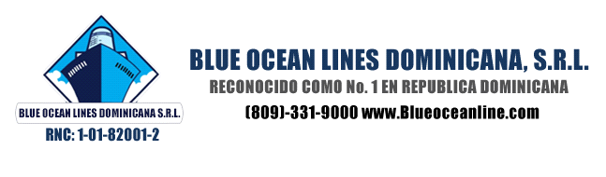
Declaration of Drain and Disconnect.

Booking number: 00001987
Shiplane Transport Reference No.: 100002885.

Container Number:
Vin Number: 2T3R1RFV7KW052624.
Trucker:

To Whom It May Concern, this letter is to certify that:
- All vehicles included in this container are drained of fuel and ran until stalled.
- All batteries are disconnected.
- No undeclared hazardous materials are containerized, secured to, or stowed in this vehicle.
- Vehicle has been properly blocked and braced in container.
- Fumes have been purged from the gas tank.
- The keys have been removed from the vehicle.
- The vehicle does not contain any additional cargo other than its own essential parts and accessories.

Signature:
Date: Enero 24,2020.
Print name: Peter F. Kennedy.

